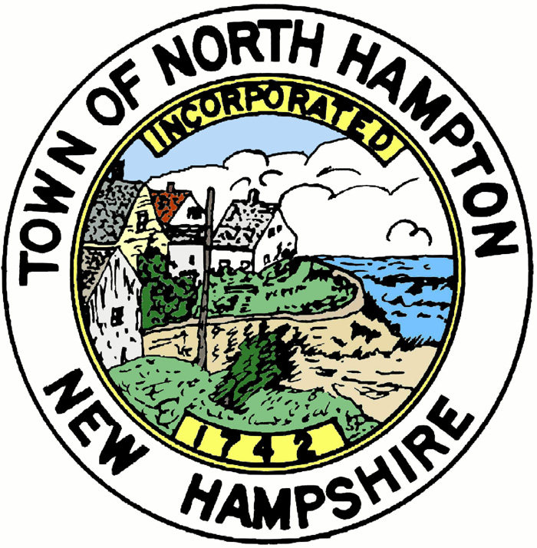
AGENDA
TOWN OF NORTH HAMPTON
Planning Board
Long Range Planning Committee
Wednesday, February 10, 2016 at 9:00am
Town Office Conference Room
233 Atlantic Avenue

The Long Range Planning Committee will meet on Wednesday, February 10, 2016 at 9:00am in the Town Office conference room to discuss the 2016 Town-wide survey.

Posted: February 5, 2016
Town Clerk’s Office
Town Office
Library
www.northhampton-nh.gov
Respectfully submitted,

Dan Derby
Planning Board

